Write a program to print types of triangles taking lengths of 3 sides from user using nested if else statement.EXPERIMENT NO. 2

Title: Python Control Flow
Aim: Implement programs using control statements: branching and looping using python.
Objective: To implement the program on control flow statements in Python.
Contents:
- if statement
- if-else statement
- Nested if-else statement
https://www.javatpoint.com/python-if-else
- For statement
https://www.javatpoint.com/python-for-loop
- While statement
https://www.javatpoint.com/python-while-loop
- Break statement
https://www.javatpoint.com/python-break
- Continue statement
https://www.javatpoint.com/python-continue
- Pass statement
https://www.javatpoint.com/python-pass

Problem Statements to perform in lab:
Simple if:
Problem stmt1: Input the age and print “Adult”, if that age is greater than 18.
Code:
age = int(input("Enter your age: "))

if age > 18:
print("Adult")
Output:
Enter your age: 45
Adult
If-else:
Problem stmt2: Find whether entered number is odd or even
Code:
number = int(input("Enter a number: "))

if number % 2 == 0:
print("Even")
else:
print("Odd")
Output:
Enter a number: 7
Odd
Else if ladder:
Problem stmt3: Write a program to print types of triangles taking lengths of 3 sides from user using nested if else statement.
- A triangle is equilateral triangle, If it's sides are equal.
- A triangle is isosceles triangle, If any two sides of a triangle are equal.
- A triangle is scalene triangle, If none of the sides are equal
Code:
a = float(input("Enter side 1: "))
b = float(input("Enter side 2: "))
c = float(input("Enter side 3: "))

if a + b > c and b + c > a and a + c > b:
if a == b and b == c:
print("Equilateral triangle")
else:
if a == b or b == c or a == c:
print("Isosceles triangle")
else:
print("Scalene triangle")
else:
print("Not a valid triangle")
Output:
Enter side 1: 40
Enter side 2: 40
Enter side 3: 10
Isosceles triangle
Problem stmt4: Input marks of five subjects from user, calculate percentage and print grade
Code: marks1 = float(input("Enter marks for subject 1: "))
marks2 = float(input("Enter marks for subject 2: "))
marks3 = float(input("Enter marks for subject 3: "))
marks4 = float(input("Enter marks for subject 4: "))
marks5 = float(input("Enter marks for subject 5: "))

#Total and percentage
total = marks1 + marks2 + marks3 + marks4 + marks5
percentage = (total / 500) * 100 # assuming each subject is out of 100

print(f"Percentage: {percentage:.2f}%")
#grade based on percentage
if percentage >= 90:
print("Grade A")
elif percentage >= 80:
print("Grade B")
elif percentage >= 70:
print("Grade C")
elif percentage >= 60:
print("Grade D")
elif percentage >= 50:
print("Grade E")
elif percentage >= 40:
print("Pass")
else:
print("Fail")
Output:
Enter marks for subject 1: 80
Enter marks for subject 2: 85
Enter marks for subject 3: 70
Enter marks for subject 4: 75
Enter marks for subject 5: 90
Percentage: 80.00%
Grade B

Percentage range | Grade
>=90 | Grade A
80-89 | Grade B
70-79 | Grade C
60-69 | Grade D
50-59 | Grade E
40-49 | Pass
<40 | Fail
Looping- While :
Problem stmt5: Count number of digits in given number
Code:
num = int(input("Enter a number: "))
num = abs(num)

count = 0

if num == 0:
count = 1
else:
while num > 0:
num = num // 10
count += 1
print("Number of digits:", count)
Output:
Enter a number: 857432
Number of digits: 6
Problem stmt6: Check Whether entered number is Armstrong (of any no. of digits)
Code:
n = int(input("enter the number:"))
temp = n
sum = 0
power=len(str(n))
while temp>0:
digit = temp %10
sum += digit ** power
temp //= 10
if n ==sum:
print ("armstrong number")
else:
print ("not an armstrong number")
Output:
enter the number:153
not an armstrong number
not an armstrong number
armstrong number
Problem stmt7: Accept the binary representation of number and display the corresponding decimal equivalent.
Looping- for
Problem stmt8: Check number is prime or not
Problem stmt9: check no. of vowel and consonant in string
Problem stmt10: print given pattern
*
**
***
****
*****
Problem Stmt11: print given Pattern
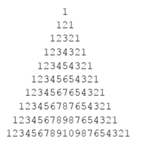

Project to implement:
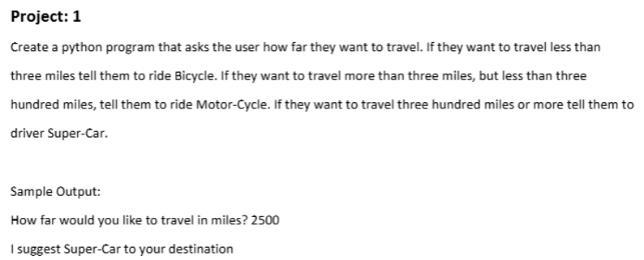

Conclusion:
Write the crux of the experiment. Here crux means very important point, complicated and again it should be understandable by you. Do not write conclusion like thus we have studied the ……… in Python programming.

Additional Program List: (Solve extra)
- Write a c program to print "Hello" 10 times on console using while , do-while and for loop.
- Write a c program to print sum of first 100 natural numbers using do while loop
- Write a c program to factorial of entered number using while loop
- Write a c program to print sum of all even numbers using do while loop.
- Implement a program to compute sum of 1+x¹+x²+x³+…x^{n} ,Using while loop
- Write a program to find the number of digits in given number.
- Check Whether the Given 3 digit Number is an Armstrong Number using while loop.
An Armstrong number of three digits is an integer such that the sum of the cubes of its digits is equal to the number itself. For example, 371 is an Armstrong number since 3**3 + 7**3 + 1**3 = 27+343+1=371
- Write a program to find the reverse of the number
- Print the all odd number from 1 to 100 using for loop
- Write a program to calculate the sum of digits in given number using do while loop. (e.g. 1324=4+2+3+1=10).
- Write a program to check given number is palindrome or not using do while loop.
N=reverse (N)
- Pattern programs
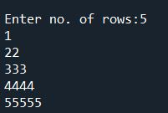 | 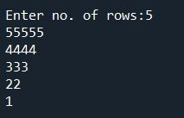 | 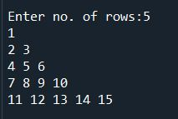
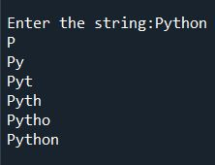 | 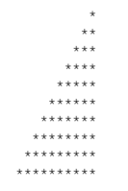 | 